Linked Lists
Suppose that you want to write a program that manages the payroll functions for a large corporation. One of the things that this program might need is a list of all of the employees working for the company. One of the attributes of this list is that the employees are kept in the list in alphabetical order. When a new employee is hired, their name must be inserted into the list in the appropriate place. When an employee leaves the company, their name must be taken out of the list without leaving a hole in the list. One way to do this is to store these employee names in a Linked List.

The Node class
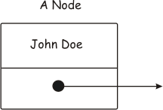
A Linked List is composed of a series of Nodes. Each node contains some data, in our case an employee name, and a pointer to the next Node. The figure here shows a single node containing the employee name "John Doe". The arrow is a pointer to the next node. If this were the only node, or the last node in a list, the pointer would be set to NULL. The class definition for this Node class might look something like the following:
class Node
{
private:
string name;
Node* next;
public:
string getName( );
void setName(string);
Node* getNext( );
void setNext(Node*);
};
Notice that the pointer's type is Node*. This is because this pointer contains the address of the next node. We store the employee's name in a string. To complete our Node, we add getters and setters for these two data members.
A set of Nodes linked together might then look like:
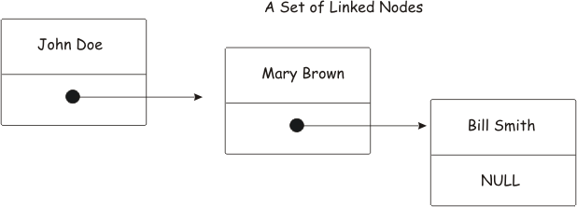

The List Class
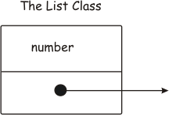
To be able to operate on this set of Node objects, we need another class that represents the entire linked list. The data members of this class are a count of the number of Node objects in the list, and a pointer to the first Node object in the list. What operations might you want to do to a list? Let's look at just a couple ... add a Node to the front of the list, and remove a node from the front of the list. We will use terminology common to the Vector class to do this. Our class definition would then look something like
class List
{
private:
int number;
Node* first;
public:
string getNumber( );
void push_front(Node* );
void pop_front( );
};
How do we add a Node to the front of the list? Consider the following diagram.
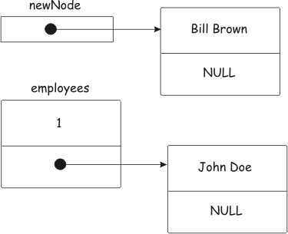
Here, we have a linked list that contains a single Node, John Doe. We want to add the Node that contains Bill Brown to the front of the list. Let the variable newNode contain the address of the Node object containing the name Bill Brown. Let our List object be named employees. Here is what we have to do:
- Get the address of the first Node in the list. Save it in a Node* variable called currentNode.
Node* currentNode = first;
We now have
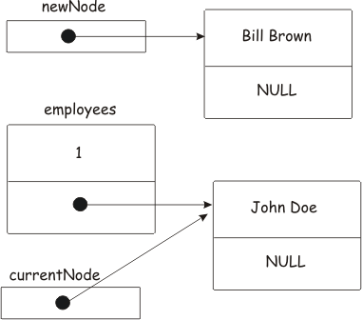

- When we add our new Node to the list, it must point to the current Node containing the name John Doe. Since we have the address of this Node object in currentNode we can store it in the Node* data member of the Node we are adding to the list. Recall that the Node* newNode contains the address of this node.
newNode->setNext(currentNode);
We now have
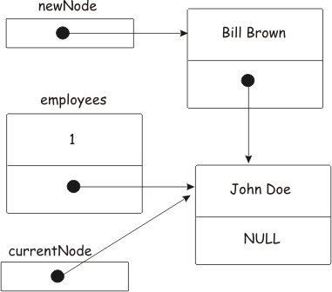

The new node now points to the current node. All we have to do at this point is save the address of the new node in the List object.
first = newNode;
And we end up with
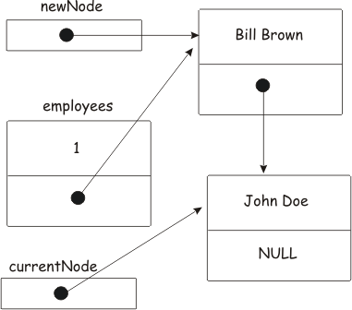

Now our List object points to the node containing the name "Bill Brown", and the node containing the name "Bill Brown" points to the node containing the name "John Doe". Increment the number of nodes in the list, and the complete push_front( ) function then looks like
void List::push_front(Node* newNode)
{
Node* currentNode = first;
newNode->setNext(currentNode);
first = newNode;
number++;
}
Now let's remove the front node in the list. Consider the following figure:
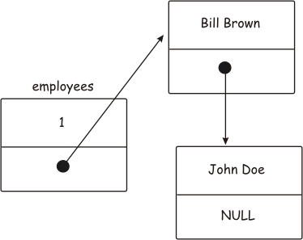

The pop_front( ) function does not return anything. It simply unlinks the front node in the list, and returns its storage to the heap. The following code would do this:
void List::pop_front( )
{
Node * saveFirst = first;
first = first->getNext( );
delete saveFirst;
number--;
}
The functions to add and remove a node from the end of the list are complicated by the fact that our List object only points to the first node in the list. You could solve this problem by adding an additional pointer to the list object that always points to the last node in the list.
Adding or removing a node from the middle of the list are also more complicated because you have to get the address of the node in the list that you want to insert the new node in front of. These ideas are discussed in the slide set on linked Lists.

